# What is Machine Learning?

Machine Learning

* Field of study that gives computers the ability to learn without being explicitly programmed

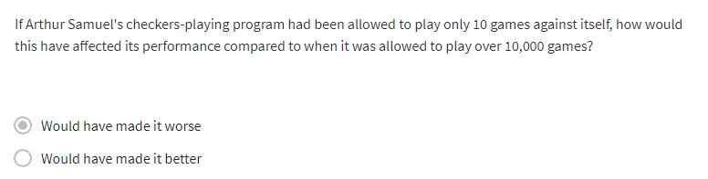

Machine Learning Algorithms

* Supervised learning
  + Used most in real-world applications
  + Rapid advancements
* Unsupervised learning
* Recommender systems
* Reinforcement learning

Goal for this course:

* Practical advice for applying learning algorithms effectively
* Best practices

# Supervised Learning

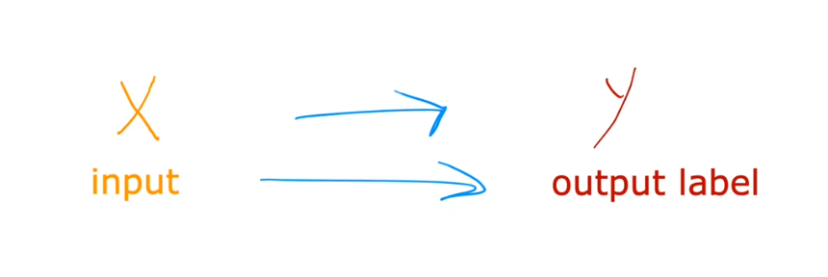

* Learns from being given the “right answers”

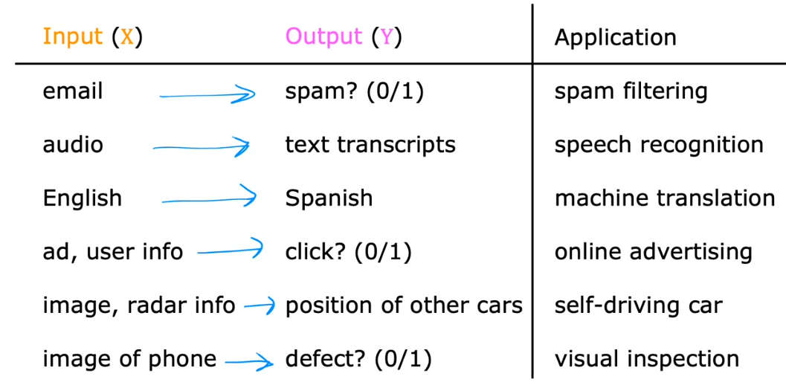

## Regression Algorithm

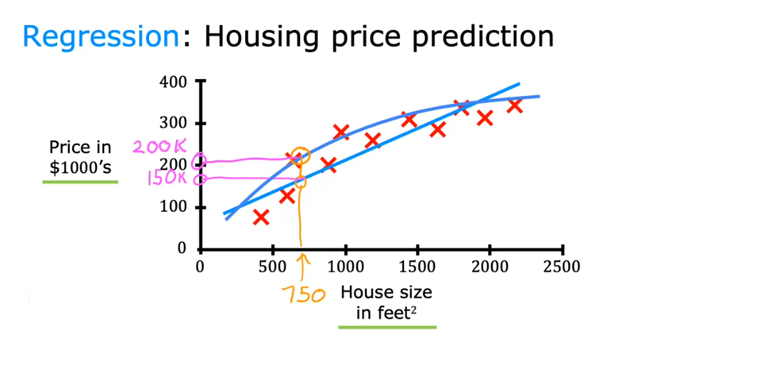

* Regression Algorithms
  + Type of supervised learning algorithm
  + We gave datasets on the House Size vs Price in $1000’s
  + *Predict a number infinitely many possible outputs*

## Classification Algorithm

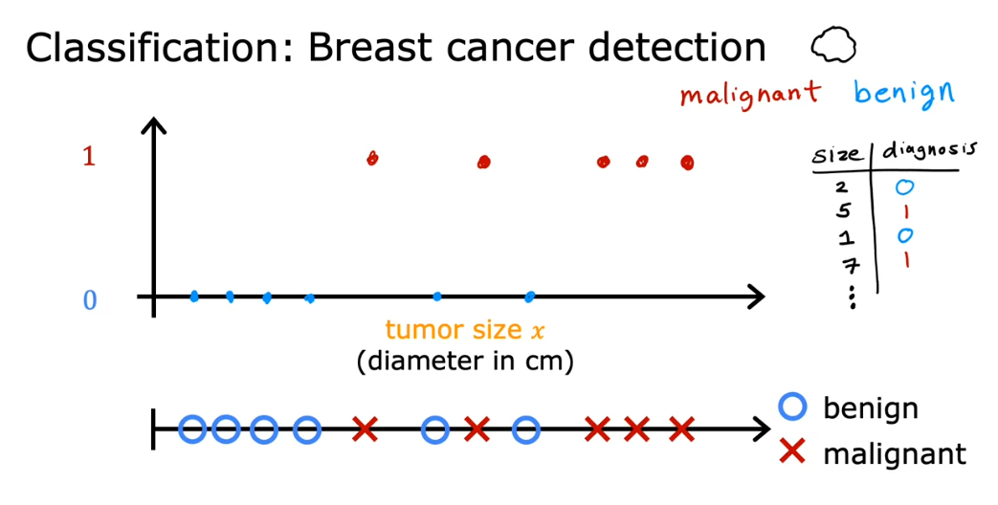

* Classification algorithm with 2 possible outputs

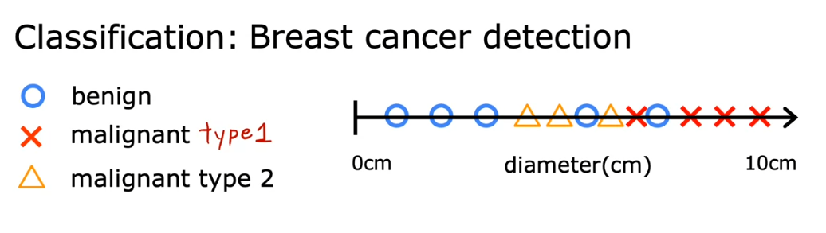

* Classification algorithm with more than 2 possible outputs

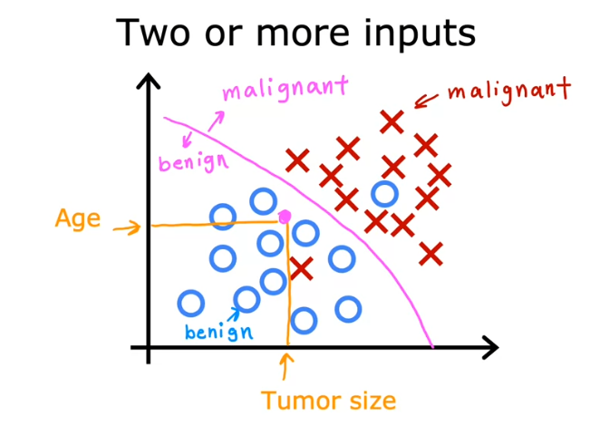

* Classification algorithm with 2 or more inputs

### Summary of Classification

* *Predict categories (aka classes, classification) or a small number/finite number of possible outputs*

## Summary of Supervised Learning

* Learns from being given “right answers”
* 2 major types
  + Regression
    - Predict a number
    - Infinitely many possible outputs
  + Classification
    - Predict categories
    - Small/finite number of possible outputs

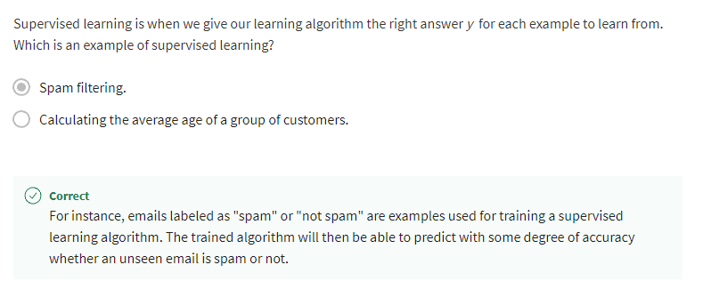

# Unsupervised Learning

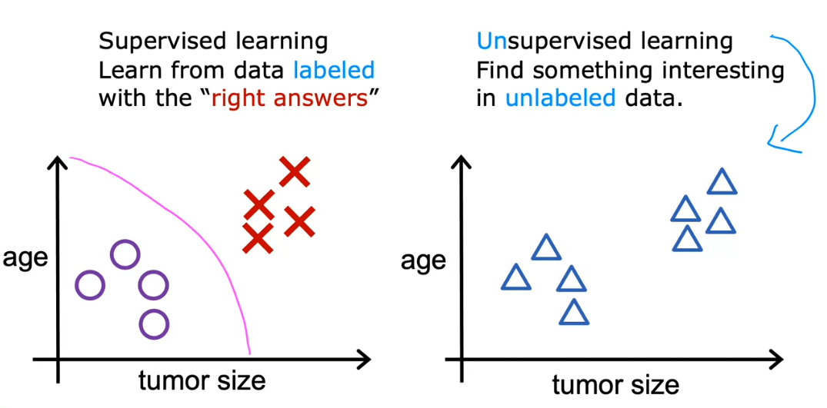

* Not giving any labels in the data set
* Data only comes with inputs x, but not output labels y
* Algorithm **has to find structure** in the data

## Clustering

* Group similar data points together

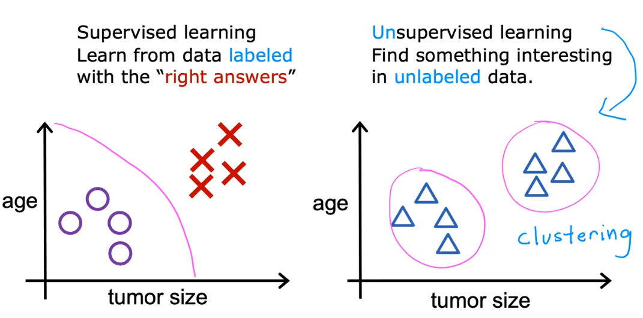

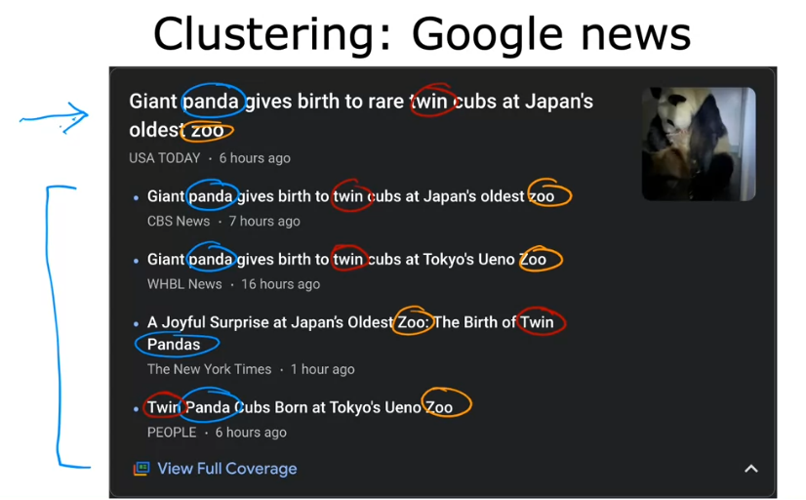

* Finding similar words and grouping them in a group
  + The algorithm figured it out on itself

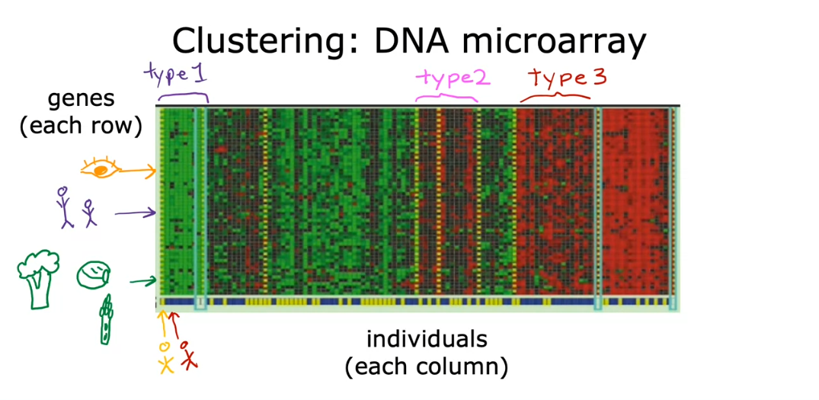

* We are not telling the algorithm that there are type 1, type 2, type 3
* Automatically find a structure in a data

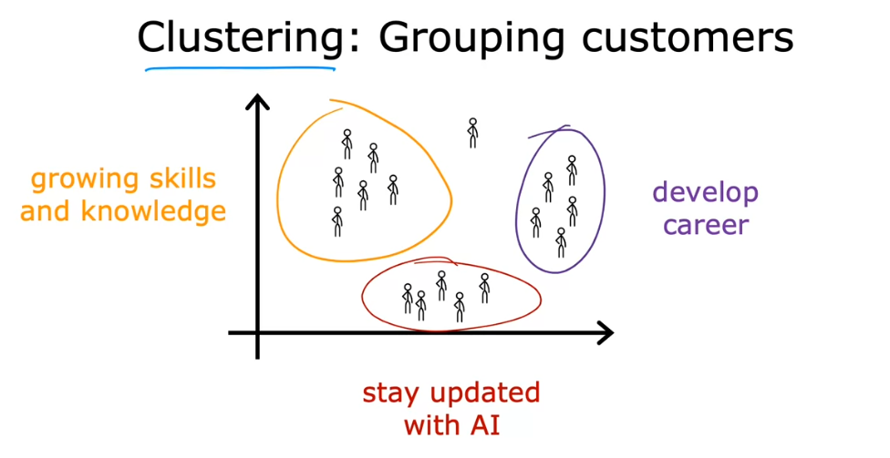

## Anomaly detection

* Find unusual data points

## Dimensionality reduction

* Compress data using fewer number
* From big data set to small data set

